

***Software Engineering Department***

***Braude College***

***Recommendation-Based Digital Library System***

***Capstone Project Phase A***

*Yuval Zohar*

*Amit Perets*

***Supervisor:***

*Dr Naomi Unkelos Shpigel*

Table of Contents

Abstract 4

1. Introduction 4

2. BACKGROUND AND RELATED WORK 5

2.1 Digital Libraries 5

2.1.1 Nowadays 6

2.2 Recommendation systems 8

2.2.1 Hybrid recommendation models 9

2.3 Database Systems 9

2.3.1 Relational Databases: Characteristics and Use Cases 9

2.3.2 NoSQL Databases: Characteristics and Use Cases 9

2.3.3 Comparative Analysis 10

2.4 Web technologies 11

2.4.1 Front-End Technologies 11

2.4.2 Back-End Technologies 11

2.4.3 Security Considerations 12

2.4.4 Accessibility and Performance Optimization 12

3. Engineering Process 12

3.1 Process 12

3.1.1 Understanding the Issue and Reviewing Existing Solutions 12

3.1.2 Requirements Gathering 13

3.1.3 Current application screens 20

3.1.4 System Design and Planning 21

3.1.5 Constraints 22

3.2 Product 23

3.2.1 Diagrams & Architectures 23

3.2.2 Algorithms 29

3.2.3 DB Structure 29

3.2.4 Screens 31

3.2.5 Tests 37

4. Expected Achievements 39

4.1 Success Criteria 40

5. Conclusions 40

6. References 41

6.1 Books websites links 41

7. GIT 41

8. AI Tools 42

8.1 Prompts examples 42

9. Appendix 42

9.1 Users questionnaire 42

Figures

Figure 1 - Moshav Kanaf Library 14

Figure 2 - Questionnaire: Results for Question 1 14

Figure 3 - Questionnaire: Results for Question 3 15

Figure 4 - Questionnaire: Results for Question 4 16

Figure 5 - Questionnaire: Results for Question 6 17

Figure 6 - Current application screens 20

Figure 7 - Flowchart of Recommendation System via Web Scraping 21

Figure 8 - System architecture diagram 23

Figure 9 - Use Case Diagram 24

Figure 10 - Login/Registration activity diagram 25

Figure 11 - Logged in user flow activity diagram 26

Figure 12 - Recommendation system activity diagram 27

Figure 13 - Class Diagram 28

Figure 14 - Screens: profile and history page 31

Figure 15 - Screens: Login page 31

Figure 16 - Screens: signup page 32

Figure 17 - Screens: reset password page 32

Figure 18 - Screens: search book page 33

Figure 19 - Screens: order book + recommendations page 33

Figure 20 - Screens: admin panel page 34

Figure 21 - Screens: book collection page 34

Figure 22 - Screens: update book page 35

Figure 23 - Screens: add book page 35

Figure 24 - Screen: borrow requests page 36

Figure 25 - update book copy page 36

Figure 26 - Appendix: Users questionnaire 42

# Abstract

Our project introduces a digital library system for Moshav Kanaf, aiming to overcome the limitations caused by its current, outdated system, which is exclusively used by the library staff and not accessible to users. The project aims to develop an inclusive digital library accessible to both users and the administrative team, featuring a recommendation system based on web scraping data from book recommendation websites and employing modern, innovative technologies for an enhanced user experience. We will also implement waiting lists for books to efficiently manage book availability and address user demand. This addition will significantly enhance the user experience by providing a structured approach to accessing high-demand titles and ensuring that the system remains user-focused and efficient. This new system offers a user-friendly platform that simplifies access to digital resources and provides personalized content recommendations. By adopting advanced technology, the updated digital library system will significantly enhance user engagement and satisfaction, advancing Moshav Kanaf's library services into the modern digital age. This project signifies a significant shift towards delivering library services that prioritize accessibility, personalization, and technological innovation, addressing the community's growing needs.

# 1. Introduction

Nowadays, libraries are no longer just physical spaces where books are stored. they have evolved into dynamic, accessible platforms offering a wealth of knowledge and resources. However, this transformation brings its own set of challenges, notably in how users discover and access content that matches their interests and needs[3]. Our project aims to address these challenges by introducing an innovative book recommendation system for our digital library website.

Digital libraries face several significant challenges that hold back their effectiveness and user satisfaction. Many digital libraries are still relying on outdated technologies, such as Microsoft Access, which can limit their performance and scalability[4]. Additionally, a notable deficiency in these platforms is their lack of personalized recommendations and adaptations for users through the use of modern algorithms. This gap means users are not receiving customized suggestions that could enhance their discovery and reading experience. Moreover, some of the smaller and local libraries utilize digital systems that are exceedingly difficult to navigate and use. This combination of outdated technology, a lack of personalization, and user-unfriendly systems presents a substantial barrier to accessing and enjoying the wealth of knowledge that digital libraries are meant to offer[4].

Existing solutions for modernizing digital libraries vary, with some libraries incrementally updating their infrastructure, which often remains behind current standards. While basic recommendation features are common, using simple algorithms based on genre or popularity, they lack deep personalization for individual users. A few digital libraries utilize AI and machine learning to enhance search and recommendations, but challenges such as financial constraints limit extensive adoption, especially in smaller libraries.

Our proposed solution aims to enhance the functionality and user experience of digital libraries through the implementation of advanced technology. Given the absence of a large-scale database or API for Hebrew books, we recognized the necessity of alternative approaches to achieve AI-based recommendations system and power our recommendation engine effectively. Specifically, we aim to implement a web scraping system customized to gather data and provide personalized book suggestions through a recommendation engine. This system will analyze individual user interactions and reading preferences, utilizing this data to offer customized recommendations that align with each user's unique interests.

The stakeholders in our digital library enhancement project encompass a diverse range of libraries, from small local libraries with outdated or non-existent digital systems to large, well-resourced libraries that are somewhat modern but not fully leveraging the latest technological advancements, especially in the domain of artificial intelligence within their digital library systems.

For small libraries that currently operate with older digital systems or lack a digital presence altogether, our solution offers a significant opportunity for transformation. By implementing our recommendations engine and updating their digital interfaces, these libraries can advance to the leading edge of digital library services. This upgrade will enable them to offer personalized book recommendations to their users, greatly enhancing the user experience and accessibility of their collections.

In summary, our project targets the transformation of digital libraries into more dynamic, personalized, and user-friendly platforms.

# 2. BACKGROUND AND RELATED WORK

## 2.1 Digital Libraries

In the digital age, digital libraries have become crucial in the world of technology, changing how we access, preserve, and share knowledge. These virtual repositories offer an expansive array of digital resources, including books, journals, images, and multimedia content, accessible from anywhere and at any time.

The start of digital libraries is closely linked with the fast progress in computer and internet technologies. The widespread use of mobile devices has increased the possibility for digital libraries to offer universal access to information, overcoming the limits of traditional libraries[3]. This accessibility is driven by advancements in wireless communication technologies, like 4G and Wi-Fi, which allow smooth access to digital collections and make information access more widespread than ever before.

At the heart of digital libraries is the integration of sophisticated technologies. These systems merge the latest in software engineering, database technology, and network infrastructure to offer robust solutions for information storage, retrieval, and management. The architecture of digital libraries, often based on the browser-server model, ensures users can access resources through web browsers on various devices, showcasing the system's platform independence and ease of maintenance[3].

Furthermore, the theoretical foundations of digital libraries, embodied in frameworks like the '5S' (Streams, Structures, Spaces, Scenarios, Societies), provide a lens for understanding the complexities of these systems. This conceptual approach helps in the creation of digital libraries that are not only technologically advanced but also centered around user needs, ensuring effective service delivery[4].

The journey of developing and implementing digital libraries is marked by challenges such as digital rights management, data preservation, and user interface design. However, the incorporation of emerging technologies, including cloud computing and artificial intelligence, into digital library systems offers new solutions to these challenges. These advancements promise to enhance the functionality and user experience of digital libraries, making them more intuitive and responsive.

Digital libraries stand as a testament to the power of modern technology to make knowledge accessible and to preserve it for future generations. By breaking down geographical and temporal barriers, they provide immediate access to an extensive information repository. As digital libraries continue to evolve, they will undoubtedly play a main role in the digital information age, shaping the future of information access and knowledge dissemination.

### 2.1.1 Nowadays

In today's digital world, there are many different digital library websites, each showing different levels of commitment to modern technology and principles. Some platforms are at the forefront, using the latest technology to improve accessibility and the user experience, while others stick to older methods and don't fully use the newest technological advancements. This difference highlights the ongoing need for innovation in digital libraries, pointing out the importance of regular updates and the integration of new technologies and principles. These efforts are crucial for improving search functions, user interfaces, and access to digital resources, making sure they stay valuable and relevant in a quickly changing digital environment. Modernization is more than just updating technology; it's about changing how users interact with digital information to make it more intuitive, engaging, and efficient. There are various ways to tackle these challenges, from simple software and hardware updates to adding basic recommendation features. Yet, many libraries still don't fully use artificial intelligence and machine learning to make user experiences more personal, often because of budget and technical limitations, especially in smaller libraries. While there have been advancements in making user interfaces more friendly and increasing digital content, there's still a lot of potential in using modern algorithms for dynamic, personalized interactions that hasn't been fully explored yet.

We conducted a comparison between 6 digital library systems across a variety of features and elements within them, in order to highlight the standard structure of contemporary digital libraries:

1. **Israel Digital:** The Israel Digital library offers a rich collection of digital resources, including historical documents, photographs, and literature, focusing on the cultural and historical heritage of Israel.
2. **Global Digital Library:** The Global Digital Library aims to increase the availability of high-quality educational resources worldwide, primarily targeting countries with limited access to educational materials, with a strong focus on supporting children’s literacy in multiple languages.
3. **UNESCO Digital Library:** The UNESCO Digital Library provides access to UNESCO’s vast repository of publications and documents on topics related to education, science, culture, and heritage from around the world, supporting the organization's mission to promote knowledge and understanding.
4. **e-vrit:** e-vrit is a digital bookstore in Israel, offering a wide range of eBooks and digital content in Hebrew, catering to the Israeli reading audience with a variety of genres and titles.
5. **Steimatzky:** Steimatzky is Israel's oldest and largest bookstore chain, providing a vast selection of books, magazines, and multimedia products. It has a significant presence both offline in numerous locations across the country and online, serving the Israeli market with Hebrew and English literature.
6. **Audible:** Audible is a leading global provider of spoken word entertainment and audiobooks, offering a vast library of audiobooks, podcasts, and other audio products. It allows users to purchase and stream audio content from a wide range of genres on various devices.

| Library  Features | Israel digital | Global Digital Library | UNESCO Digital Library | e-vrit | steimatzky | audible |
| --- | --- | --- | --- | --- | --- | --- |
| User-Friendly Interface | תיבת סימון עם x עם מילוי מלא | תיבת סימון עם v עם מילוי מלא | תיבת סימון עם v עם מילוי מלא | תיבת סימון עם v עם מילוי מלא | תיבת סימון עם v עם מילוי מלא | תיבת סימון עם v עם מילוי מלא |
| Advanced Search | תיבת סימון עם v עם מילוי מלא | תיבת סימון עם v עם מילוי מלא | תיבת סימון עם v עם מילוי מלא | תיבת סימון עם v עם מילוי מלא | תיבת סימון עם v עם מילוי מלא | תיבת סימון עם v עם מילוי מלא |
| Mobile Compatibility | תיבת סימון עם v עם מילוי מלא | תיבת סימון עם v עם מילוי מלא | תיבת סימון עם v עם מילוי מלא | תיבת סימון עם v עם מילוי מלא | תיבת סימון עם v עם מילוי מלא | תיבת סימון עם v עם מילוי מלא |
| Recommendations  system | תיבת סימון עם x עם מילוי מלא | תיבת סימון עם x עם מילוי מלא | תיבת סימון עם x עם מילוי מלא | תיבת סימון עם v עם מילוי מלא | תיבת סימון עם v עם מילוי מלא | תיבת סימון עם v עם מילוי מלא |
| Multi-language Support | תיבת סימון עם v עם מילוי מלא | תיבת סימון עם v עם מילוי מלא | תיבת סימון עם v עם מילוי מלא | תיבת סימון עם x עם מילוי מלא | תיבת סימון עם x עם מילוי מלא | תיבת סימון עם v עם מילוי מלא |
| Technologies | ASP.NET  jQuery | jQuery  WordPress | Cloudflare  Vanilla js | React  core-js | jQuery  core-js  moment js  React | jQuery  core-js  slick js |
| Mobile application | תיבת סימון עם x עם מילוי מלא | תיבת סימון עם x עם מילוי מלא | תיבת סימון עם x עם מילוי מלא | תיבת סימון עם v עם מילוי מלא | תיבת סימון עם v עם מילוי מלא | תיבת סימון עם v עם מילוי מלא |
| Audio books | תיבת סימון עם v עם מילוי מלא | תיבת סימון עם x עם מילוי מלא | תיבת סימון עם x עם מילוי מלא | תיבת סימון עם v עם מילוי מלא | תיבת סימון עם x עם מילוי מלא | תיבת סימון עם v עם מילוי מלא |
| Ebook | תיבת סימון עם v עם מילוי מלא | תיבת סימון עם v עם מילוי מלא | תיבת סימון עם v עם מילוי מלא | תיבת סימון עם v עם מילוי מלא | תיבת סימון עם v עם מילוי מלא | תיבת סימון עם v עם מילוי מלא |

* For Audible, some of the books have a partnership with Amazon Kindle, so they provide audiobooks and EBOOKS together.

## 2.2 Recommendation systems

In the evolving landscape of digital libraries, the integration of recommendation systems has emerged as a crucial strategy to enhance user experience and engagement. These systems leverage various algorithms and data processing techniques to analyze user behavior, preferences, and interactions within the library's digital resources. By doing so, they can offer personalized suggestions that significantly reduce the time users spend searching for relevant information and materials. The fundamental concept of such systems is to create a more intuitive and responsive digital environment, where users can discover content that aligns with their interests and research needs more efficiently.

The sophistication of recommendation systems in digital libraries has evolved from simple rule-based algorithms to more complex models that utilize machine learning and deep learning techniques [6]. These advanced models are capable of understanding user preferences and predicting future needs with greater accuracy. By analyzing extensive datasets, including borrowing histories, search queries, and interaction patterns, these systems can identify patterns and trends that inform more targeted recommendations [8]. Furthermore, the integration of multimodal data, such as textual, visual, and auditory information, has enriched the recommendation process, offering a holistic approach to understanding user preferences [9].

A critical aspect of these systems is their adaptability and scalability. As digital libraries grow and the diversity of their user base expands, recommendation systems must continuously learn and adjust to new information and changing user behaviors [6]. This dynamic nature ensures that the recommendations remain relevant and valuable over time, enhancing user satisfaction and engagement with the library's resources.

Moreover, the implementation of recommendation systems in digital libraries also addresses the challenge of information overload. With the exponential growth of digital content, users can easily become overwhelmed by the expanded array of available resources. Recommendation systems serve as a filter, prioritizing content based on predicted relevance to the user's interests, thereby simplifying the discovery process [8]. This not only improves the efficiency of information retrieval but also increases the likelihood of users encountering unexpected discoveries that might not have been found through traditional search methods.

The impact of these systems extends beyond individual user experiences, contributing to the overall improvement of library services. By analyzing the data on user interactions and preferences, libraries can gain insights into trends and gaps in their collections, guiding strategic decisions regarding purchases and resource allocation [5]. This data-driven approach enables libraries to adapt their offerings more closely to the needs and interests of their community, enhancing the library's role as an important resource for research, learning, and personal development.

The adoption of recommendation systems within digital libraries marks a shift towards a more interactive and personalized user experience. These systems, through their advanced algorithms and data processing capabilities, offer an effortless way to navigate the huge amount of digital content. As we look forward to the future, the role of recommendation systems in enriching digital libraries and users through customized content suggestions is extremely valuable.

### 2.2.1 Hybrid recommendation models

Hybrid recommendation models combine different techniques to improve how recommendations are made. They address the weaknesses of methods like content-based filtering, which relies on item details, and collaborative filtering, which uses user ratings. These hybrid models come in seven types:

1. Weighted Hybridization: Adjusts how much each method contributes based on how well it matches what the user likes.
2. Switching Hybridization: Changes the method used depending on the situation.
3. Cascade Hybridization: Uses one method to pick items and another to rank them.
4. Mixed Hybridization: Considers a user's past behavior when making recommendations, helpful when suggesting many things at once.
5. Feature Combination: Uses one method for some item data and another for more detailed data.
6. Feature-Augmentation: Classifies item preferences with one method and then uses that info with another method.
7. Meta-Level: Simplifies how recommendations are made by using one method's results as input for another.

Most studies on hybrid models aim to solve the problem of not having enough data by combining content-based and collaborative filtering. This helps improve how well recommendations match what users like[5].

## 2.3 Database Systems

The database world is mainly divided into two specific categories: relational (SQL) and NoSQL databases. Relational databases, established in the 1970s, rely on a structured query language (SQL) for defining and manipulating data, which is organized in a tabular form and follows a strict schema. NoSQL databases, emerging in the late 2000s, are designed to accommodate a wide variety of data models, including key-value, document, wide-column, and graph formats. They offer flexibility in managing large volumes of structured, semi-structured, and unstructured data[7].

### 2.3.1 Relational Databases: Characteristics and Use Cases

Relational Database Management Systems (RDBMS) are particularly effective in scenarios that demand data integrity and transactional consistency. They are fitted for applications that require complex queries and transactions, such as financial systems, inventory management, and other applications that requires complex joins and data integrity, ensuring ACID (Atomicity, Consistency, Isolation, Durability) properties[7].

### 2.3.2 NoSQL Databases: Characteristics and Use Cases

Conversely, NoSQL databases are distinguished by their scalability and flexibility, designed to spread data across multiple servers or nodes, making them ideal for large-scale, distributed data environments. They are characterized by their lack of a fixed schema, allowing for the easy addition or modification of data structures without significant system interruptions. NoSQL databases are particularly fitted for big data applications, real-time web apps, social networks, e-commerce platforms, and IoT systems, where the data model is expected to evolve[7].

### 2.3.3 Comparative Analysis

1. **Data Model Flexibility**: NoSQL databases provide significant flexibility in data models, supporting key-value pairs, documents, graphs, or wide columns, as opposed to the strictly tabular approach of relational databases.
2. **Scalability**: NoSQL databases excel in horizontal scalability, efficiently distributing data across multiple nodes or servers. In contrast, relational databases typically scale vertically, requiring more powerful server hardware to increase capacity.
3. **Schema Flexibility**: The schema-less or flexible schema nature of NoSQL databases facilitates rapid development and iteration, allowing new data types and structures to be added with minimal schema design.
4. **Transactions**: While relational databases are known for supporting complex transactions and ensuring strict data integrity through ACID properties, NoSQL databases often offer eventual consistency (BASE model) instead of strict consistency, balancing transaction integrity with scalability and performance.
5. **Query Language**: SQL, employed by relational databases, is a powerful and widely adopted language for data querying and manipulation. NoSQL databases, however, utilize a variety of query languages and APIs, customized to their specific data models, which may not offer the same depth as SQL for complex queries.
6. **Use Cases**: Relational databases are the preferred choice for applications that involve complex joins, transactions, and other operations on structured data. NoSQL databases are more fitted to scenarios requiring scalability, flexibility in data type handling, and high-performance operations on distributed systems.

The selection between relational and NoSQL databases connections on specific application requirements, including data volume, complexity, scalability needs, and operational flexibility. As technology continues to evolve, hybrid models that combine the strengths of both relational and NoSQL databases are becoming increasingly common, offering solutions for many data management challenges[7].

MongoDB and Firebase are both popular examples of NoSQL databases, each offering unique features and advantages for different use cases.

**MongoDB:**

Advantages: Highly scalable, supports complex queries and deep aggregation operations. It offers flexibility with schema-less design, making it suitable for applications requiring fast iterations. MongoDB's document-oriented model allows for storing nested data structures directly.

Disadvantages: Relatively complex setup and management for partitioning and duplication. It might require more infrastructure management compared to fully managed solutions.

MongoDB offers a powerful platform for applications that need to handle large amounts of data with complex structures and queries. It fits for applications where the data schema can evolve over time.

**Firebase**:

Advantages: Fully managed, real-time database service with effortless integration with other Google services. Firebase excels in building quick prototypes, offering special solutions for user authentication, hosting, and cloud functions. The real-time synchronization is ideal for applications that require instant data updates.

Disadvantages: While offering ease of use, Firebase can become expensive, and the query capabilities are somewhat limited compared to MongoDB.

Firebase provides a more complete backend-as-a-service (BaaS) solution with features like user authentication, which makes it highly attractive for developers looking to minimize backend development time and focus on the client side.

The choice between MongoDB and Firebase depends on the specific requirements of the project, including the complexity of data handling, scalability needs, and the desire for a managed service with integrated backend capabilities.

## 2.4 Web technologies

Developing a digital library system with a recommendation engine involves a complex interplay of both front-end and back-end web technologies. This section will explore the essential technologies and frameworks that can be utilized to build such a system, distinguishing between front-end and back-end components.

### 2.4.1 Front-End Technologies

The front-end of a digital library involves the user interface and experience aspects—how users interact with the library, browse books, receive recommendations, and view their reading histories. The common technologies:

1. **HTML, CSS, and JavaScript**: The foundation of any web application, these technologies enable the creation of structured content, styled and interactive elements, respectively[1].
2. **Front-End Frameworks (React, Angular, Vue.js)**: These JavaScript frameworks and libraries offer platforms for developing dynamic and responsive user interfaces. They help the development of single-page applications that can update content dynamically without reloading the page, enhancing the user experience[1].

### 2.4.2 Back-End Technologies

The back-end of the digital library handles data management, server interactions, recommendation algorithms, and user authentication. It is crucial for storing user data, book information, and generating personalized recommendations.

1. **Server-Side Languages (PHP, Python, Node.js)**: These languages are used to develop the logic that runs on the server, handling requests from the front end and communicating with the database[1].
2. **Databases (MySQL, MongoDB, PostgreSQL)**: Essential for storing user data, book catalogs, and reading histories. The choice between SQL (e.g., MySQL, PostgreSQL) and NoSQL (e.g., MongoDB) databases depends on the application's data structure and scalability requirements.
3. **Recommendation Engine Algorithms**: Implementing machine learning algorithms (e.g., collaborative filtering, content-based filtering) on the server-side to analyze user behavior and provide personalized book recommendations.
4. **Web Scraping Tools (Beautiful Soup, Scrapy):** These tools are utilized to gather data from various online sources, such as bookstores or literary databases. They facilitate the extraction of information like book titles, authors, descriptions, and reviews, which can enrich the database and enhance the recommendation engine's effectiveness.

### 2.4.3 Security Considerations

Security is extremely important in protecting user data and ensuring trust in the digital library system. Implementing HTTPS, secure coding practices, input validation, and regular security assessments are crucial steps in mitigating potential security issues[1].

### 2.4.4 Accessibility and Performance Optimization

Ensuring the digital library is accessible to all users, including those with disabilities, is essential. This involves following to web accessibility standards and implementing performance optimization techniques such as paging, efficient database queries and more, to enhance the overall user experience[1].

Building a digital library system with a recommendation engine is a complex task requiring a blend of front end and back end technologies. By utilizing the right technologies and focusing on user experience, security, and performance, developers can create a dynamic, efficient, and secure digital library that meets the needs of its users.

# 3. Engineering Process

The process of creating the digital library system for Moshav Kanaf is being carefully planned and executed. We've combined technical expertise with user-friendly design principles while addressing existing technological gaps. This section explains how we’re developing the system, why we choose certain methods, and the challenges we are facing.

## 3.1 Process

### 3.1.1 Understanding the Issue and Reviewing Existing Solutions

In this step, we thoroughly reviewed existing digital library platforms to learn from their successes and identify any areas where Moshav Kanaf's new system could improve. This phase was crucial for understanding the library's challenges and the latest digital library technologies. It helped us discover new features and practices to meet the needs of Moshav Kanaf's users, ensuring the new system would be up-to-date and user-friendly.

### 3.1.2 Requirements Gathering

The first phase included talking to library staff and asking users to fill out surveys to learn about their needs, preferences, and the problems with the current system. This was important to make sure the new system would focus on users and solve the current issues.

#### Interview with the library staff

We visited the library at Moshav Kanaf and conducted an interview with the staff in the presence of our supervisor, Naomi.

**Question**: What sources of information do you have? (files containing existing books, etc.)

**Answer**: In fact, we don't even have access to the Data base on which the system works. We tried to contact the system developers in order to obtain the DB, without any success. However, it is also possible to receive reports in various formats of the system's users, of the books in the system, and of all the loans in the system. It should be considered that it is possible that there are duplicates / lack of data in all reports due to many malfunctions in the current system.

**Question**: How is the process of borrowing books carried out?

**Answer**: A reader comes to the library, and we advise them on a book based on their interests. If there's no available copy, we manually add them to the waitlist. If there is an available copy, we give it to them and mark it in the system. However, sometimes the registration in the system doesn't "stick", and we don't always catch it. As a result, there's sometimes no record in the system, and we lose track of the book. Books can also get lost this way.

Additionally, because the system is very complex and difficult to search for an existing book, there are situations where it takes us a few minutes to find it during the borrowing process, and sometimes we don't find it at all even though we know the book should be in the library.

Our goal is to simplify the search process and be able to track every book, even in terms of late returns.

**Question**: How would you like the borrowing process to be carried out in the new system?

**Answer:** A reader will log into the system and search for the book they are interested in. Of course, they can also physically come to the library and receive recommendations from us. On the website, the customer will be able to see whether the book is currently available in the library or if it is borrowed by another customer. They will be able to sign up for the waitlist and even receive a notification when the book is returned to the library. If the book is currently available in the library, they can request to borrow it, and all that's left is for the librarians to approve the request, and the customer will come to the library to pick up the reserved book.

**Question**: How are book recommendations currently made?

**Answer**: Currently, customers tend to come to the library and tell the librarians what genres of books they like or books they have read and enjoyed in the past, and based on that, they receive recommendations from the librarians who recommend books to customers according to their experiences. Of course, it can be understood that we librarians do not know all the books, so it is difficult to recommend a specific book to every reader.

**Question**: How would you like recommendations to be made in the system?

**Answer**: It is possible to integrate reviews from various websites on the internet, such as "e-vrit", which provides reliable reviews. The reader will be able to look at the website and receive recommendations from the system according to the history of the books they have read (based on the category of those books, "people who read this book also read..."), or alternatively, they can browse among the different books and look at the ratings and comments given by readers who have read the book.

**Question**: Do you have similar websites that you think can serve as inspiration? What do you like about them and what not?

**Answer**: We really like "e-vrit" website; it's very well-organized and includes a wide variety of books. It has a delicate and simple design.

The design aspect is something important to us to be simple and delicate in our system because our target audience might not be very tech-savvy, so it's important that using the system be easy, convenient, and customized to as many people as possible.

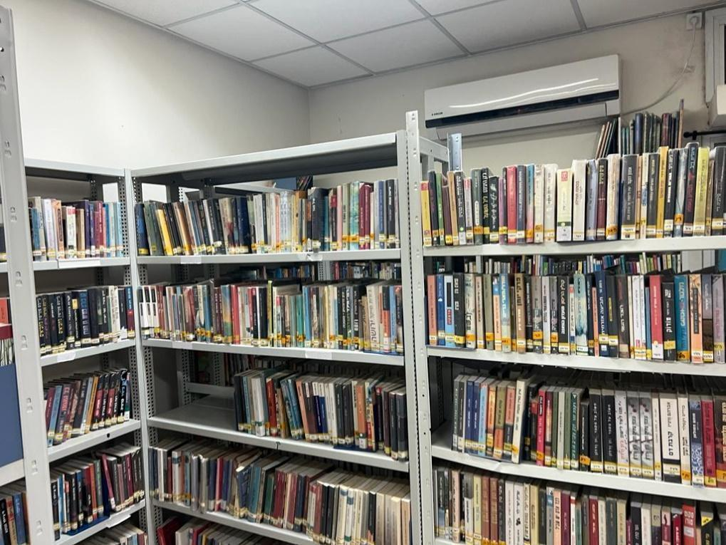

*Figure 1 - Moshav Kanaf Library*

#### Questionnaires for users

We conducted a survey using Google Docs and distributed it to residents of Moshav Kanaf, as well as to Facebook groups dedicated to books, friends, family, and general readers. The aim was to gather insights into users' preferences regarding a digital library website and refine the requirements gathering process[2] (Questionnaire in the Appendix). We received the next results:

1. The features/functionality that users rated regarding the addition to the digital system: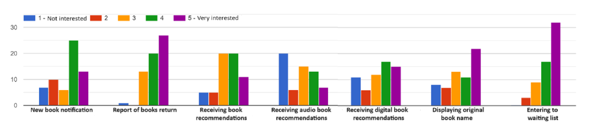
2. The additional features that users provided that may be of interest to them (part of them):

* Recommendation for books similar to ones borrowed previously.
* When a new physical book arrives in a genre I love.
* Reading books with animation assistance, for this AI could be excellent.
* Ability to create book lists/tags.
* Categories (areas of knowledge), special recommendations for publications from college staff, communication with the library team, graphical display of borrowed/overdue/waiting books, maybe statistics (delays, for example...).
* Requesting new book orders for the library.
* Notification when a requested book is available, option to request a book not currently in the library at all.
* Receiving recommendations only for my chosen genres.
* Ability to see if the book exists physically in the library or is borrowed, and it would also be nice to see which books are expected to arrive and when.
* Recommendations to include recommendations from the library team as well as recommendations and ratings from readers; to provide an option to rate and recommend as well; in digital books - an option to read the first chapter (hopefully also in printed ones, but that might be challenging to implement); an option to request books not currently in the library (to suggest the library to purchase them and add them to the database); an events board for library events (such as meetings with authors, book clubs).
* Reading the first pages of a book to get an impression. Reading comments/recommendations/reviews about the book.

From the feedback received, it's evident that users prioritize personalized book recommendations, streamlined borrowing processes, community engagement, transparent communication, and innovative features leveraging technology to enhance their reading experience.

1. Based on the feedback from this questionnaire, we recognize the critical importance of implementing a recommendation system.

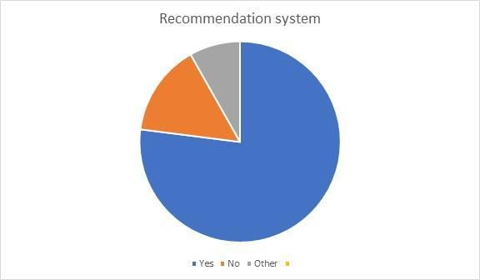

1. It can be inferred that it's crucial to develop the website to be suitable for smartphones, but it's also important for it to be responsive and adaptable for computers and tablets.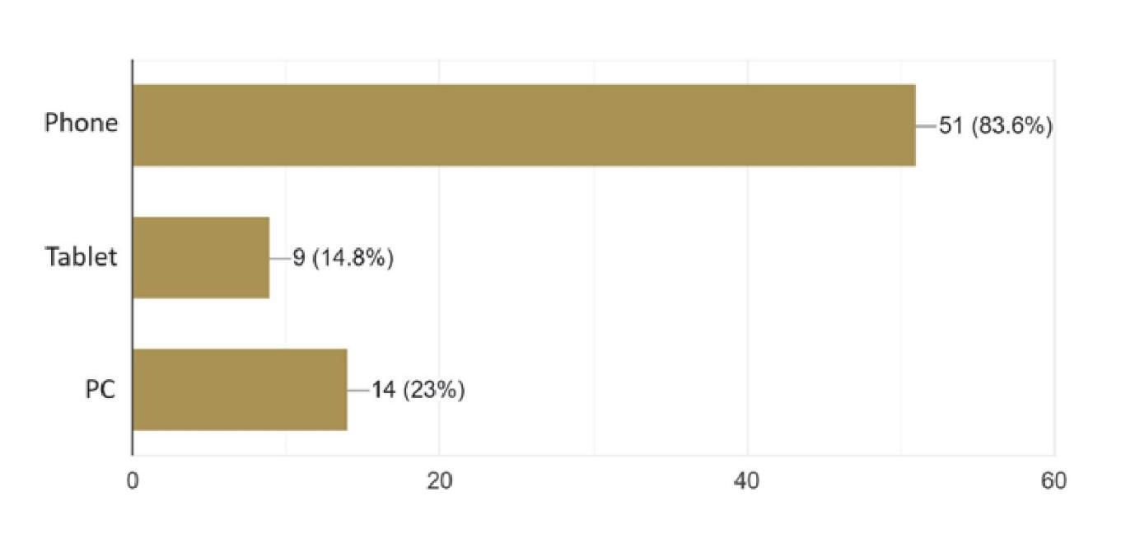
2. From the feedback of this question, it can be seen that the majority of users prefer to mark a book they dislike so that the system will not recommend it to them again in the future (part of the responses).

* Good. The algorithm needs to learn for both directions (yes/no).
* I would be happy if there was an "uninterested" option, allowing the algorithm to learn what interests me more or less and adjust future recommendations accordingly.
* Good, so the system can learn my preferences. Although it's good to receive recommendations outside of my usual preferences to be exposed to new genres.
* Not critical for me. I understand that the system may also recommend books that are not to my taste.
* I would prefer to give feedback - this book does not interest me to help the algorithm get to know me better and sharpen its recommendations.
* It depends on what was the initial factor for the recommendation, user profile matching or maybe a rating or some other incentive.
* This is an important option to provide rating for recommendations in order to better understand the customer.

1. It can be seen that the vast majority prefer to borrow physically / through the website.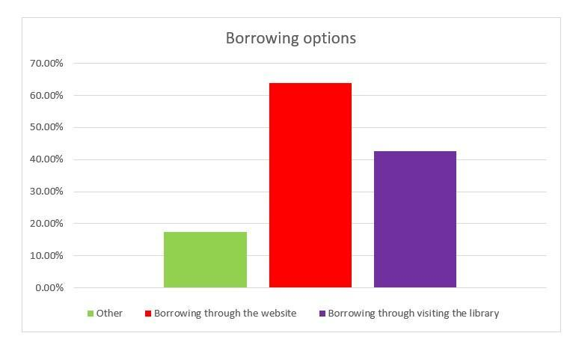
2. The recommended websites mentioned in the survey are: Kindle, Technion library, Primo library, Amazon, Audible, and Libby.
3. Additional recommendations for upgrading the website as provided by users:

* Summary for each new book.
* Efficient and advanced search.
* Efficient search. Clearing the search field in the next search with an "X".
* It's important that the website is not cluttered and easy to navigate.
* I haven't tried it yet, but the most important thing in a library is an excellent and user-friendly search engine.
* Ability to borrow audiobooks for listening while traveling.
* Having a personal platform for rating books and a personal catalog, as well as organizing books that have already been read separately.

#### Requirements

##### Functional Requirements

| No. | Requirement |
| --- | --- |
| 1 | The system allows users to register for an account. |
| 2 | The system allows users to log in. |
| 2.1 | The system allows users to logout. |
| 3 | The system securely stores passwords. |
| 4 | The system allows users to reset their passwords if forgotten. |
| 5 | The system differentiates between different roles. |
| 6 | The system grants administrators access to administrative functions. |
| 7 | The system allows for adding a book to the library. |
| 8 | The system allows for editing details of an existing book in the library. |
| 9 | The system grants readers access to regular member functions. |
| 10 | The system implements a recommendation system. |
| 11 | The system allows users to request the loan of a book. |
| 12 | The system allows administrators to confirm book loans. |
| 13 | The system allows users to enter waiting lists for each book |
| 14 | The system tracks loan status. |
| 15 | The system will allow for extending the loan period for a specific book. |
| 16 | The system notifies users of overdue books. |
| 17 | The system allows users to rate books they have read. |
| 18 | The system displays average ratings for each book. |
| 19 | The system displays reviews for each book. |
| 20 | The system allows access to the site from various devices. |
| 21 | The system allows users to view their borrowing history. |
| 22 | The system allows users to search books |
| 23 | The system allows to change user permissions |

##### Non-functional Requirements

| No. | Requirement | Classification |
| --- | --- | --- |
| 1 | User authentication will be performed using a Google account or by username and password. | Security |
| 2 | Passwords will be securely stored using Firebase. | Security |
| 3 | Password recovery will be facilitated through Firebase. | Security |
| 4 | Different user types will include admin and reader. | Flexibility |
| 5 | Admin permissions will include approving book loans, adding books to the system, extending book return dates, and managing the library's books, change permissions to user | Security |
| 6 | Reader actions in the system will include browsing, searching, borrowing, and review books, cancel borrowing, view history. | Usability |
| 7 | The recommendation system will leverage internet data, user preferences, reading history, and book ratings. | Usability |
| 8 | Tracking of book loans will be done using a defined loan date. | Availability |
| 9 | Book reviews will be conducted through a rating scale of 1-5 and comments. | Usability |
| 10 | Access to the site can be done via computers and mobile devices. | Compatibility |
| 11 | The website pages will include: login page, registration page, contact page, book searching page, borrowing history page, book borrowing page, book borrowing approval page (admin only) | Usability |
| 12 | Details to be included in book addition and editing are: book title, book code, publisher, number of copies, availability for loan, location, category. | Usability |
| 13 | book search for books by title, author, genre | Flexibility |
| 14 | User permissions changed by admin user | Usability |
| 15 | The frontend web stack includes:  ReactJS, CSS/TailwindCSS, TypeScript, Axios, Jest | Compatibility |
| 16 | The Backend Web Stack includes:  NodeJS, ExpressJS, FirebaseDB, Firebase Authenticator | Compatibility |

### 3.1.3 Current application screens

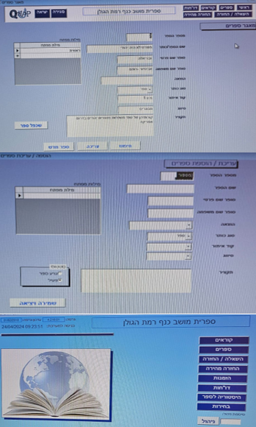

*Figure 6 - Current application screens*

### 3.1.4 System Design and Planning

Based on the requirements gathered, we advanced to the system design phase. To ensure a clear and comprehensive representation of the planned system architecture, we developed activity, use case, and class diagrams. These diagrams collectively illustrate the system's overall structure, the interactions between its components, and the flow of data throughout the system (The diagrams in the next section).

#### Books Recommendation System

The recommendation system will be designed to focus on Hebrew literature and ensure high-quality suggestions. To achieve this, we turn to Hebrew books websites such as "e-vrit" website, a prominent platform offering a diverse collection of Hebrew books. Since direct access to Hebrew book databases is limited, "e-vrit" serves as our primary source for gathering book suggestions. We aim to achieve this using the concept of "Mixed Hybridization" as outlined in section 2.2.1. The book recommendation system will take into account user behavior. when a user clicks on a book they're interested in, suggested books will be provided to them.

Our process begins when someone searches for a specific book in our system. We use a scraper—an automated tool designed to collect information from websites—to locate the book on the website. After pinpointing the book, the scraper examines the website to identify additional books recommended alongside it. The scraper's ability to efficiently gather this data allows us to establish a robust database of book suggestions.

Once the scraper has compiled a list of recommended books, we cross-reference it with our library's inventory. If any of the suggested books are available in our collection, they are included in the recommendations presented to the user. This method enables us to provide customized suggestions based on reliable recommendations from a reputable source.

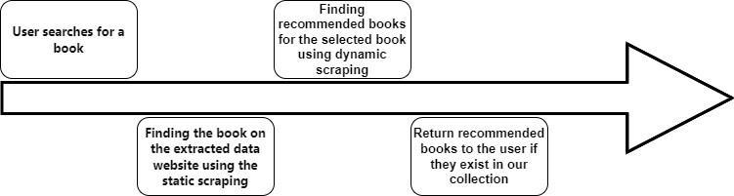

*Figure 7 - Flowchart of Recommendation System via Web Scraping*

#### Prototyping and Feedback

Early prototypes of the system will be developed and shared with a select group of users and staff for feedback. This iterative process will allow us to refine the system's features and interface based on real user interactions.

#### Development and Implementation

With the insights gained from prototyping, we will proceed to the development phase, where the system's components will be built, integrated, and tested. This will include the backend infrastructure, the recommendation engine, and the frontend user interface.

#### Deployment

The system will be deployed in a single phase, following comprehensive testing and validation. Upon deployment, continuous monitoring will be established to track the system's performance and to collect user feedback, which will be instrumental for ongoing improvements and enhancements.

### 3.1.5 Constraints

Several constraints influenced the development process:

* **Technological Limitations**: The transition from an outdated system to advanced technologies posed challenges, requiring careful selection of tools and platforms that could be integrated smoothly with existing library databases and infrastructure.
* **Budget and Time Constraints**: Limited resources necessitated prioritizing certain features over others and adopting agile development practices to maximize efficiency.
* **User Diversity**: Catering to a diverse user base with varying levels of digital literacy required the design of an intuitive and accessible interface, ensuring that all users could navigate the system with ease.
* **Data Privacy and Security**: Implementing the recommendation engine required handling user data responsibly, necessitating robust data protection measures to comply with privacy laws and build trust with users.

The engineering process for the Moshav Kanaf digital library system represents a comprehensive effort to leverage modern technologies and user-centered design to create a transformative library experience. By addressing these key areas and navigating the associated constraints, the project aims to set a new standard for digital library services.

## 3.2 Product

### 3.2.1 Diagrams & Architectures

#### System architecture diagram

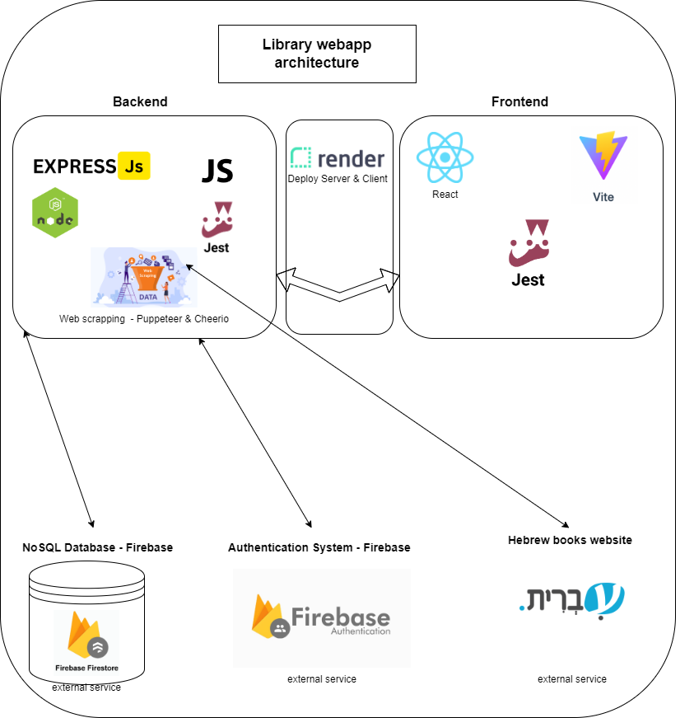

*Figure 8 - System architecture diagram*

#### Use Case Diagram

The Use Case Diagram offers a graphical overview of the interactions between users and the library system, illustrating the various operations users can perform within the system.

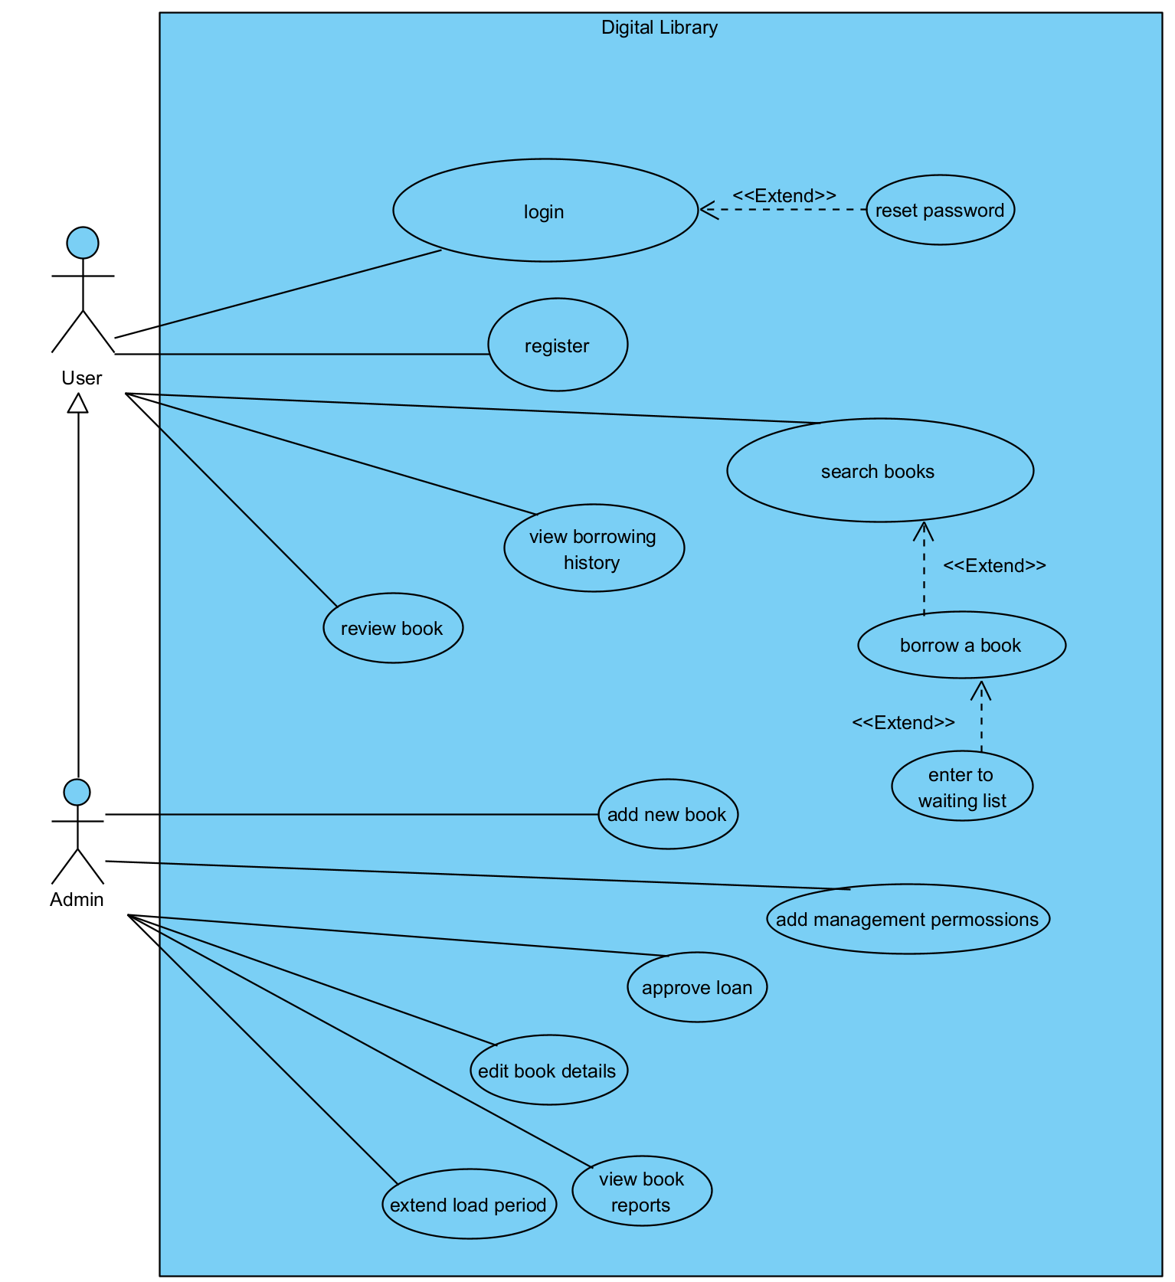

*Figure 9 - Use Case Diagram*

#### Activity diagram

The Activity Diagram visually represents the flow of activities and actions within the library system, specifically outlining how different users interact with the system, from searching and browsing digital resources to receiving personalized recommendations and managing their user accounts.

Login/Registration activity diagram:  
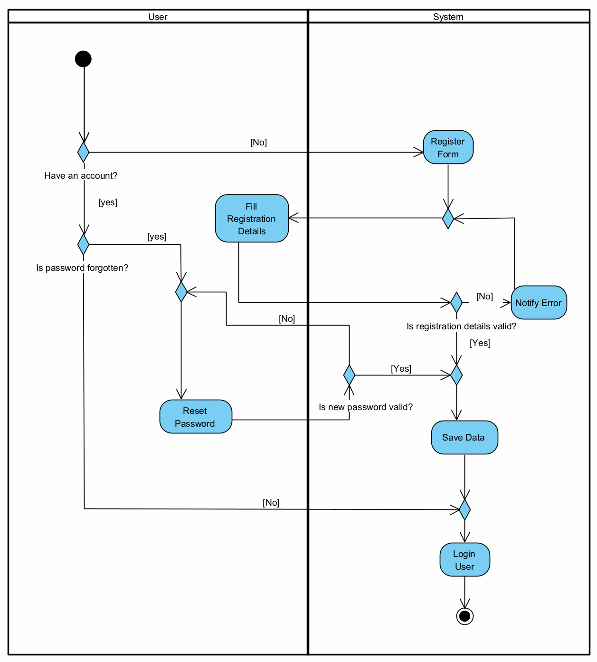

*Figure 10 - Login/Registration activity diagram*

Logged in user flow activity diagram:

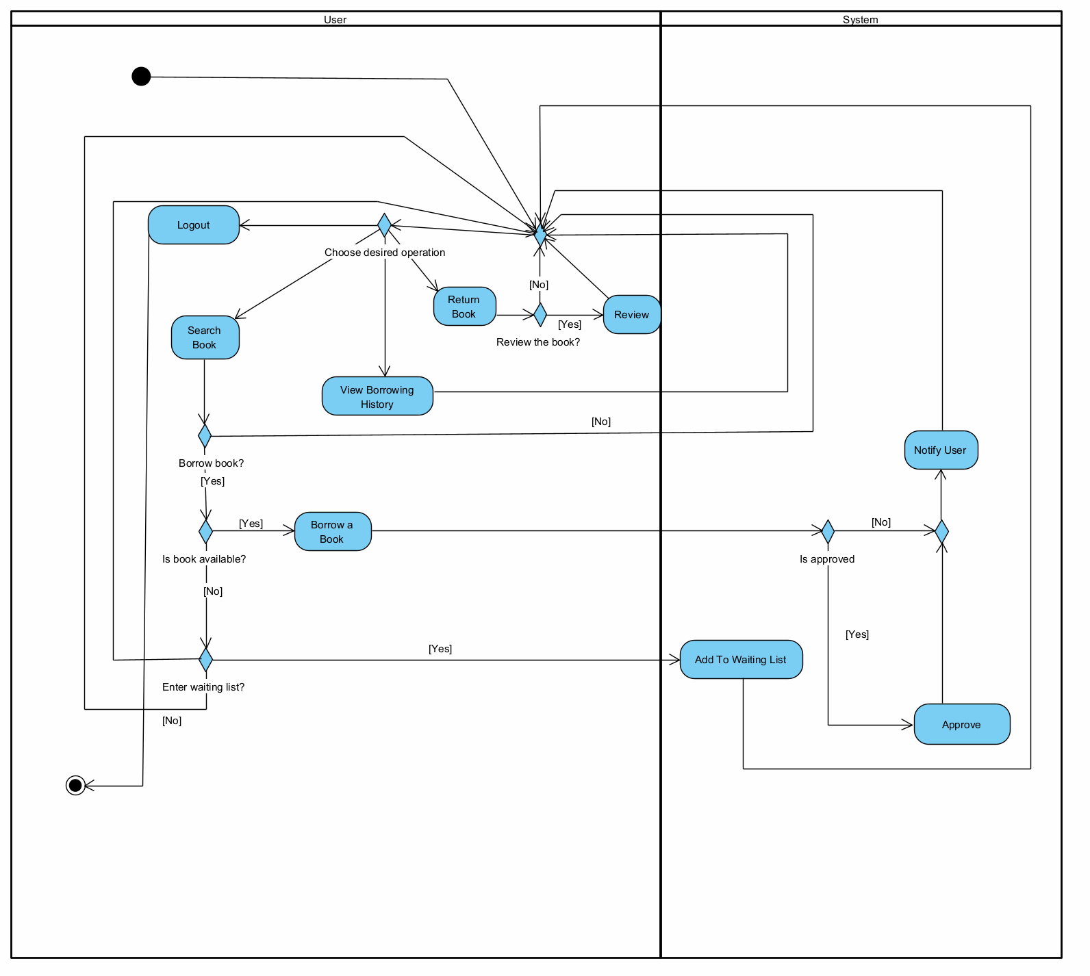

*Figure 11 - Logged in user flow activity diagram*

Recommendation system activity diagram:

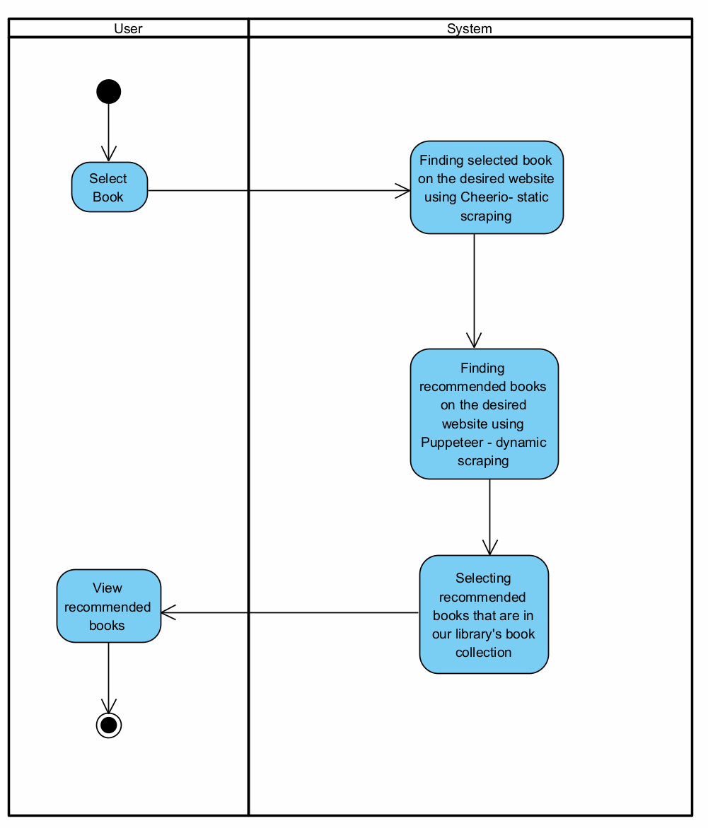

*Figure 12 - Recommendation system activity diagram*

#### Class Diagram

The Class Diagram offers a detailed structural view of the library system, depicting the system's classes, their attributes, operations, and the relationships among them, which collectively define how the system's functionality is organized and implemented.

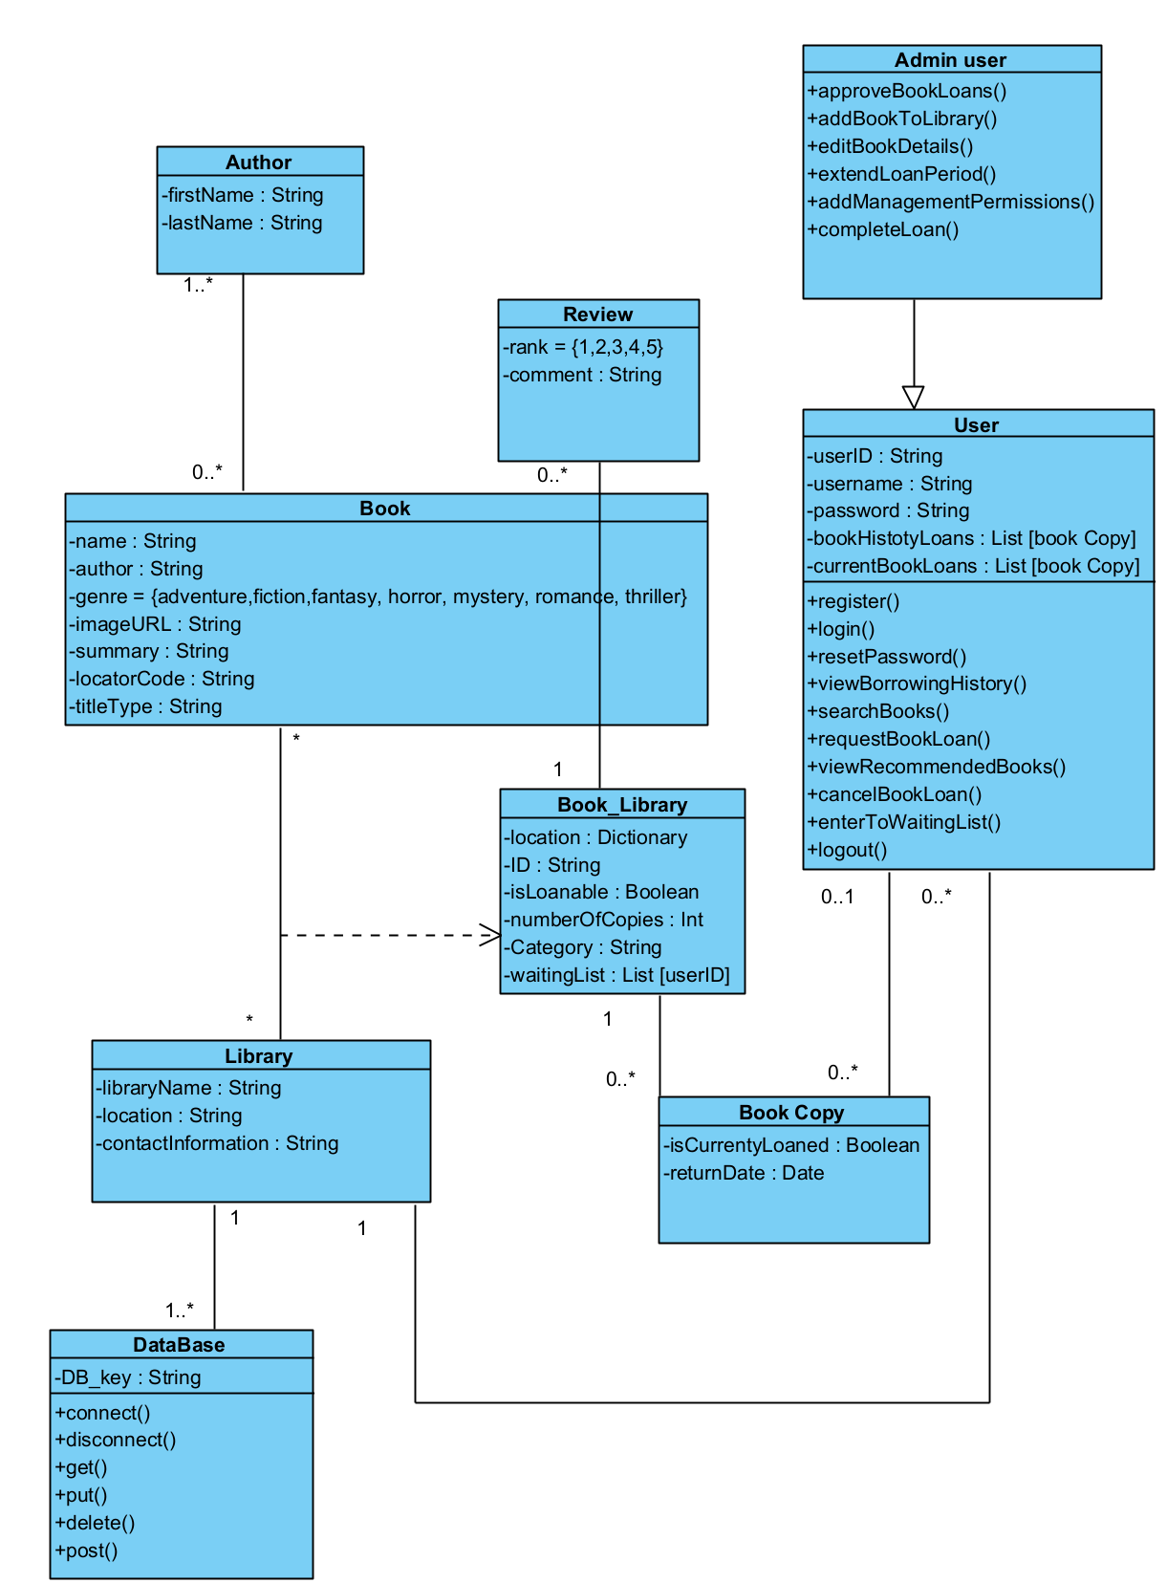

*Figure 13 - Class Diagram*

### 

### 3.2.2 Algorithms

Web scraping - Web scraping is a technique we use to collect information from websites, and it involves different tools depending on the type of content we need to access. For static websites where the content doesn’t change often, we use a tool called Cheerio[11]. Cheerio is fast and straightforward, allowing us to browse website data efficiently without actually loading it in a web browser. It's perfect for quickly grabbing data that is easily accessible on the webpage.

For more complex websites that show different information based on user interactions, like clicking buttons or filling out forms, we use a tool called Puppeteer[12]. Puppeteer acts like a person browsing a site, making it ideal for navigating and extracting data from dynamic websites. It can simulate real user actions to access content that appears in response to these actions.

In our project for Moshav Kanaf’s digital library system, we utilize both Cheerio and Puppeteer to interact with Hebrew books websites such as “e-vrit” website, a platform that sells books and recommends similar books. We specifically use Cheerio to handle the static data from the site, which is faster and less resource-intensive. Cheerio let us “search” the book in the extracted data websites. Meanwhile, we deploy Puppeteer for the dynamic aspects of the websites, such as the book recommendation system[See Figure 7, 12]. By searching for a book in the extracted data websites using Puppeteer, we can gather detailed information not only about the searched book but also about other suggested books that the website recommends. This capability allows us to tap into the website's own recommendation system to enhance our book suggestions.

Integrating this scraped data into our own library's system, we provide more personalized and diverse book recommendations to our users. This approach enriches our library service, making it more engaging and useful for people seeking new reading material. Using Cheerio for static data and Puppeteer for dynamic data ensures our library system remains cutting-edge, user-friendly, and responsive to the community's needs. By adopting these web scraping tools, our library offers broad access to various books and utilizes the latest technology to assist users in discovering books they might enjoy.

### 3.2.3 DB Structure

Books collection:

  "books": {

      "author": string,

      "classification": string,

      "copies": number,

      "copiesID": [

          string

      ],

      "expenditure": string,

      "imageURL": string,

      "locatorCode": string,

      "summary": string,

      "title": string,

  "waitingList": [users reference]

  },

Copies collection:

  "copies": {

      "borrowedTo": users reference,

      "copyID": string,

      "isBorrowed": string,

      "title": string,

  },

User Collection:

  "users": {

      "displayName": string,

      "random": number,

      "uid": string

  }

UserReporst collection:

"userReports": {

      "borrowedBooks": [

          {

              "bookTitle": string,

              "borrowTimestamp": timestamp

          }

      ],

      "uid": string

  },

bookReports collection:

  "bookReports": {

      "bookTitle": string,

      "amountOfTimesBorrowed": number,

      "toWhomItWasBorrowed": [

          users reference

      ]

  }

### 3.2.4 Screens

#### Profile and history page

On this page, users can view the books they currently possess, along with the time remaining for each book. Additionally, users can see a record of the books they have previously read.

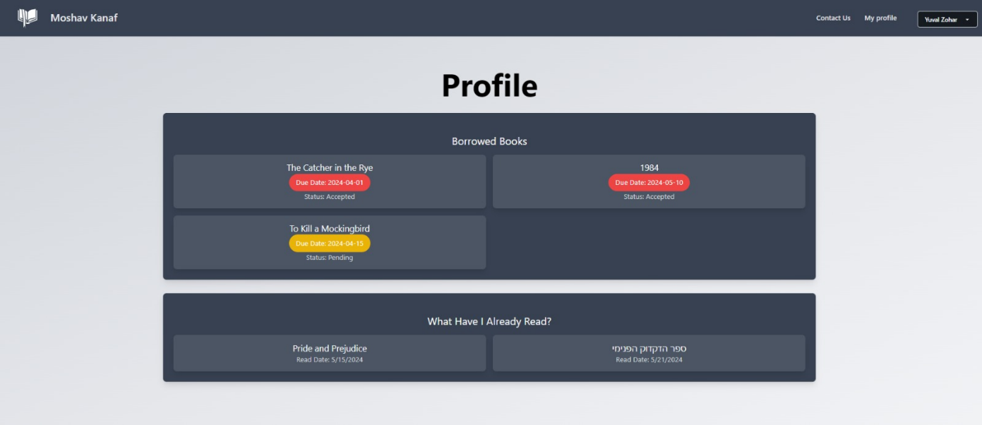

*Figure 14 - Screens: profile and history page*

#### Login and signup pages

Users have the option to sign in through Google or through a traditional sign-in process. 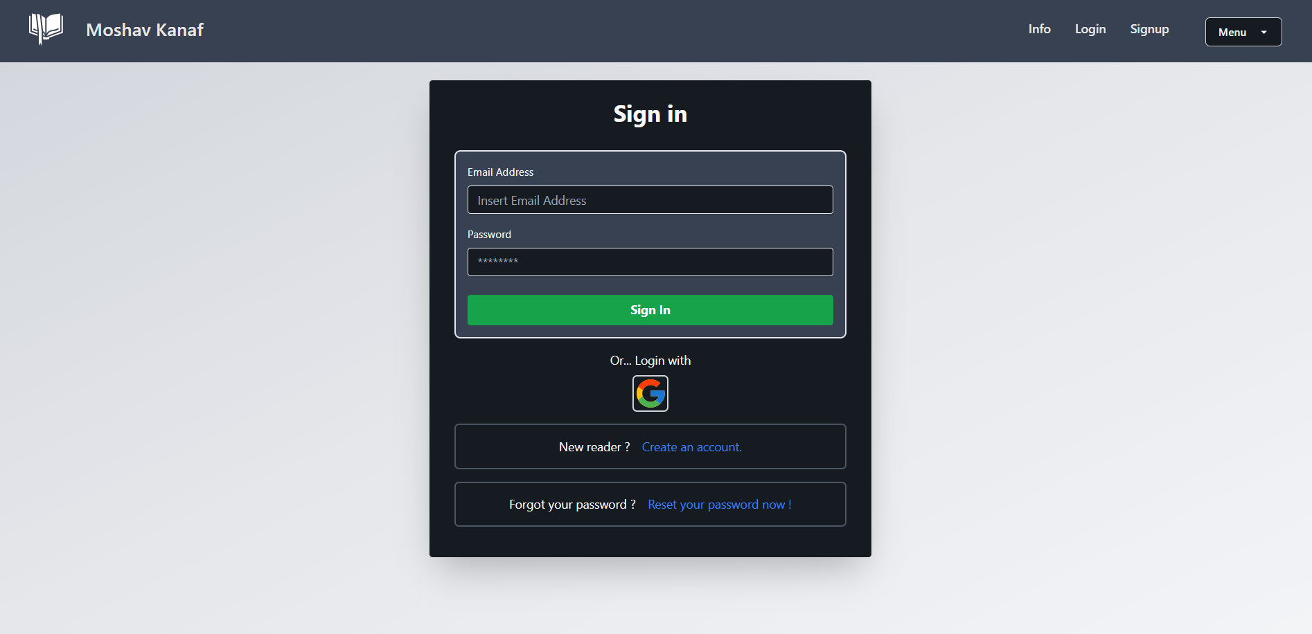

*Figure 15 - Screens: Login page*

Account creation whenever the user isn't registered. involves providing the necessary details.

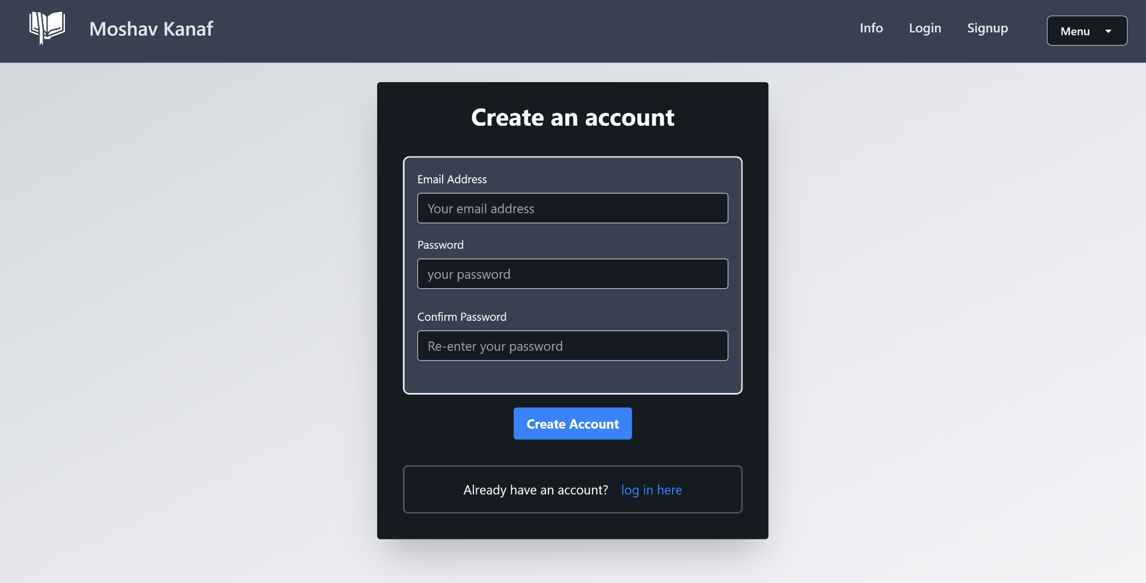

*Figure 16 - Screens: signup page*

Reset password page - there's a password reset option available in case users forget their passwords.

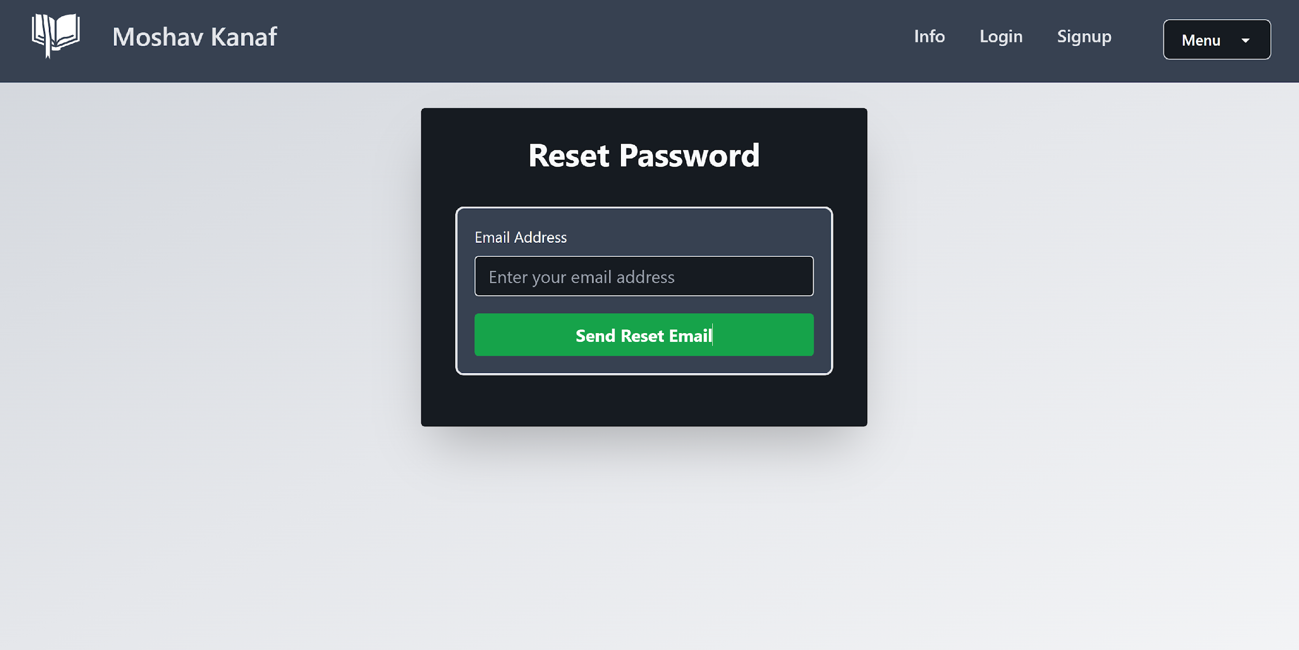

*Figure 17 - Screens: reset password page*

#### Users pages

The book search page serves as the main page for users, where they can explore and search through the entire library collection.

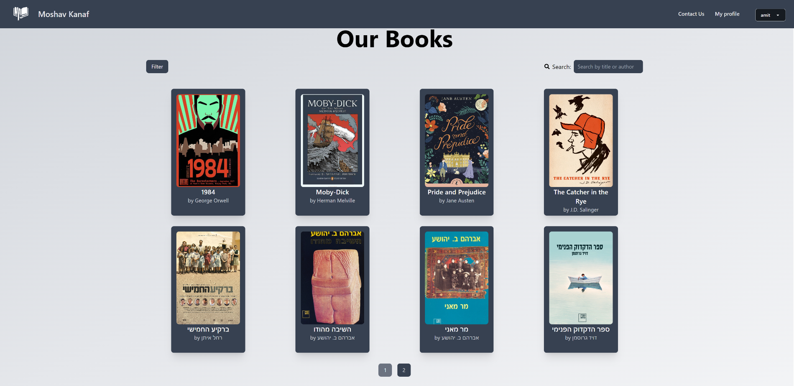

*Figure 18 - Screens: search book page*

When a user selects a book, they have the option to either place an order for it or explore recommendations displayed below the chosen book. Additionally, they can navigate to other book pages through the recommendations section.

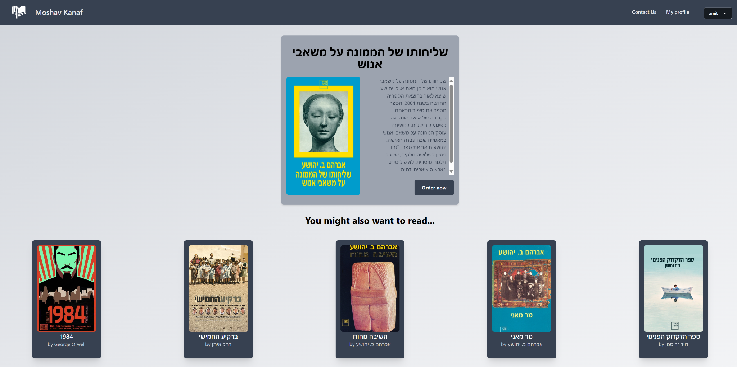

*Figure 19 - Screens: order book + recommendations page*

#### Manager pages

The manager's homepage showcases all the actions that a manager can perform, including tasks such as adding or updating books, accessing and creating borrow requests, and viewing reports.

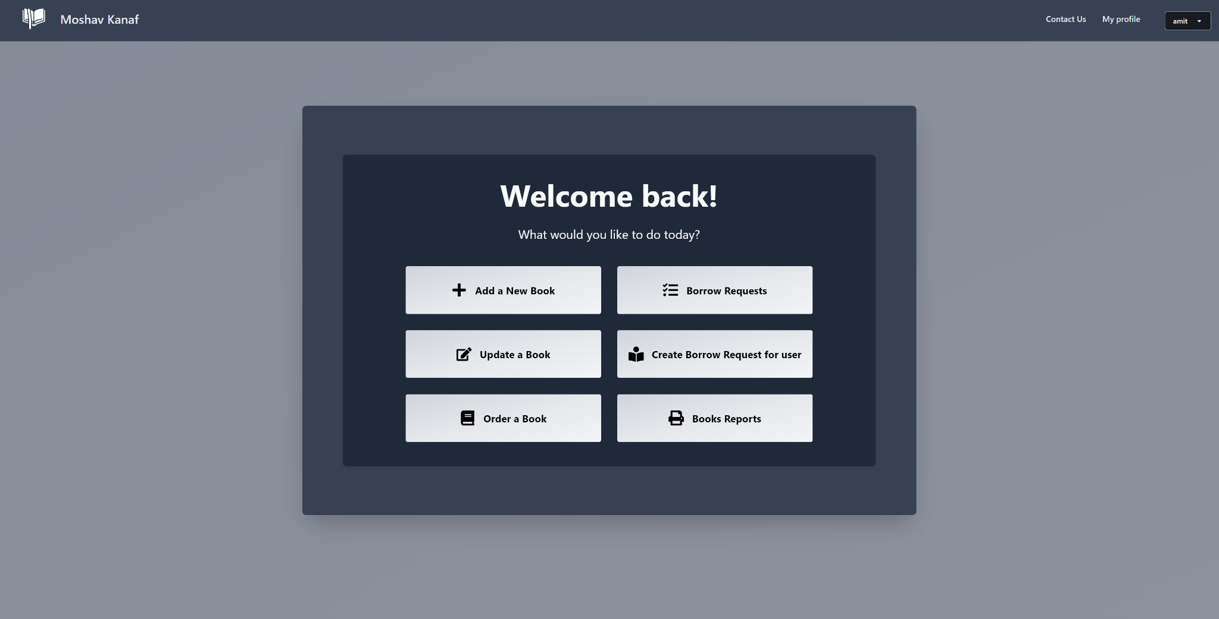

*Figure 20 - Screens: admin panel page*

On this page, the user can access the entire collection of books when they wish to update a book. Here, they can select the specific book they want to update or delete from the collection.

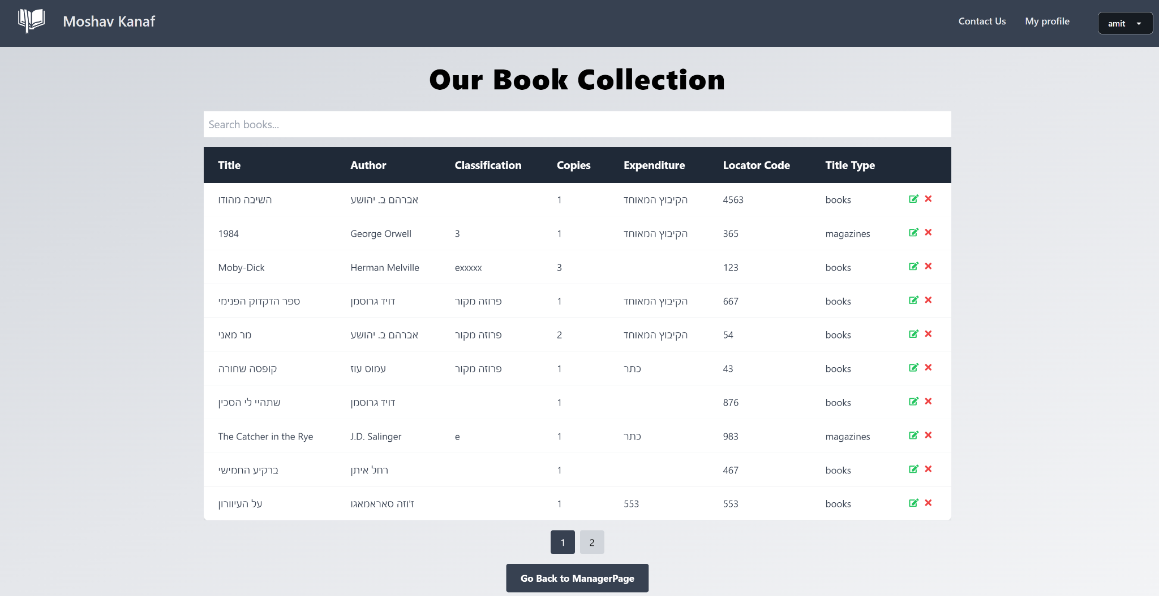

*Figure 21 - Screens: book collection page*

This is the book update page, accessed by clicking the update icon on the PresentBooksPage.

Here, the current details of the selected book are automatically displayed for the user, and they can update them as they please.

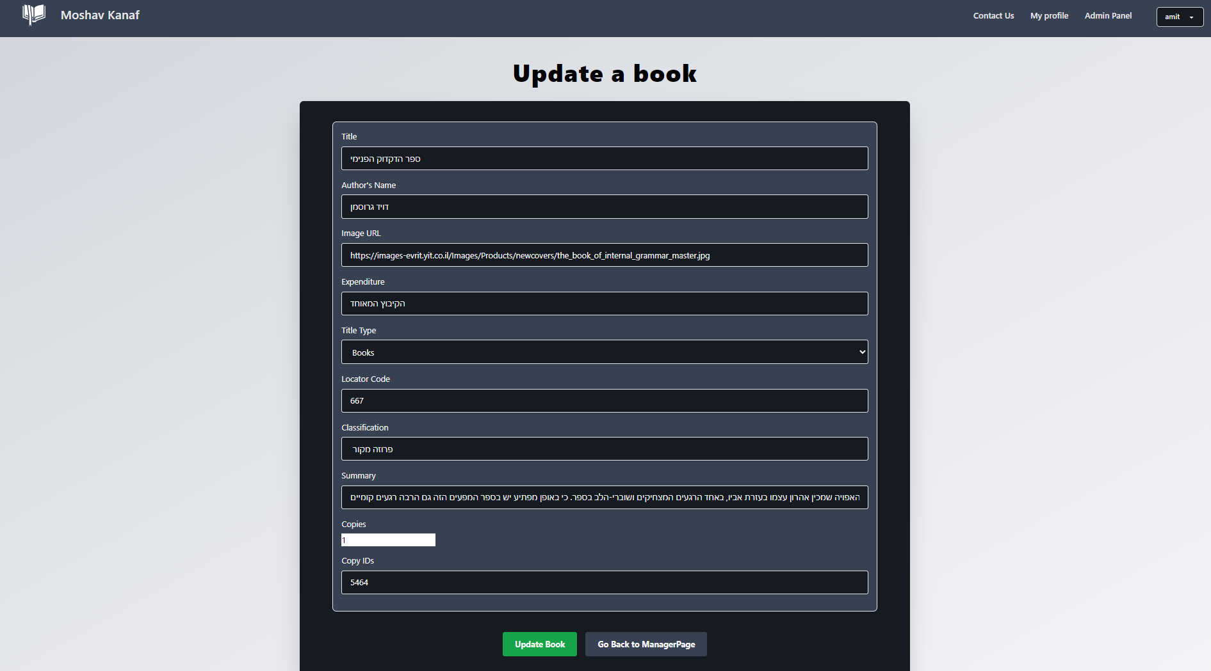

*Figure 22 - Screens: update book page*

This is the Add Book page. Here, users can put all the relevant data for each new book.

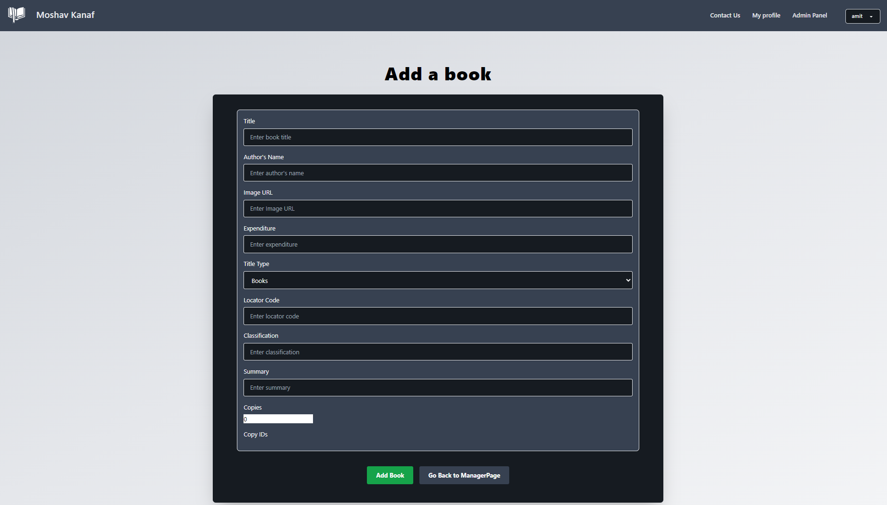

*Figure 23 - Screens: add book page*

Borrow requests page. when the user clicks the "Order Now" button, a new request with relevant details appears on this manager page.

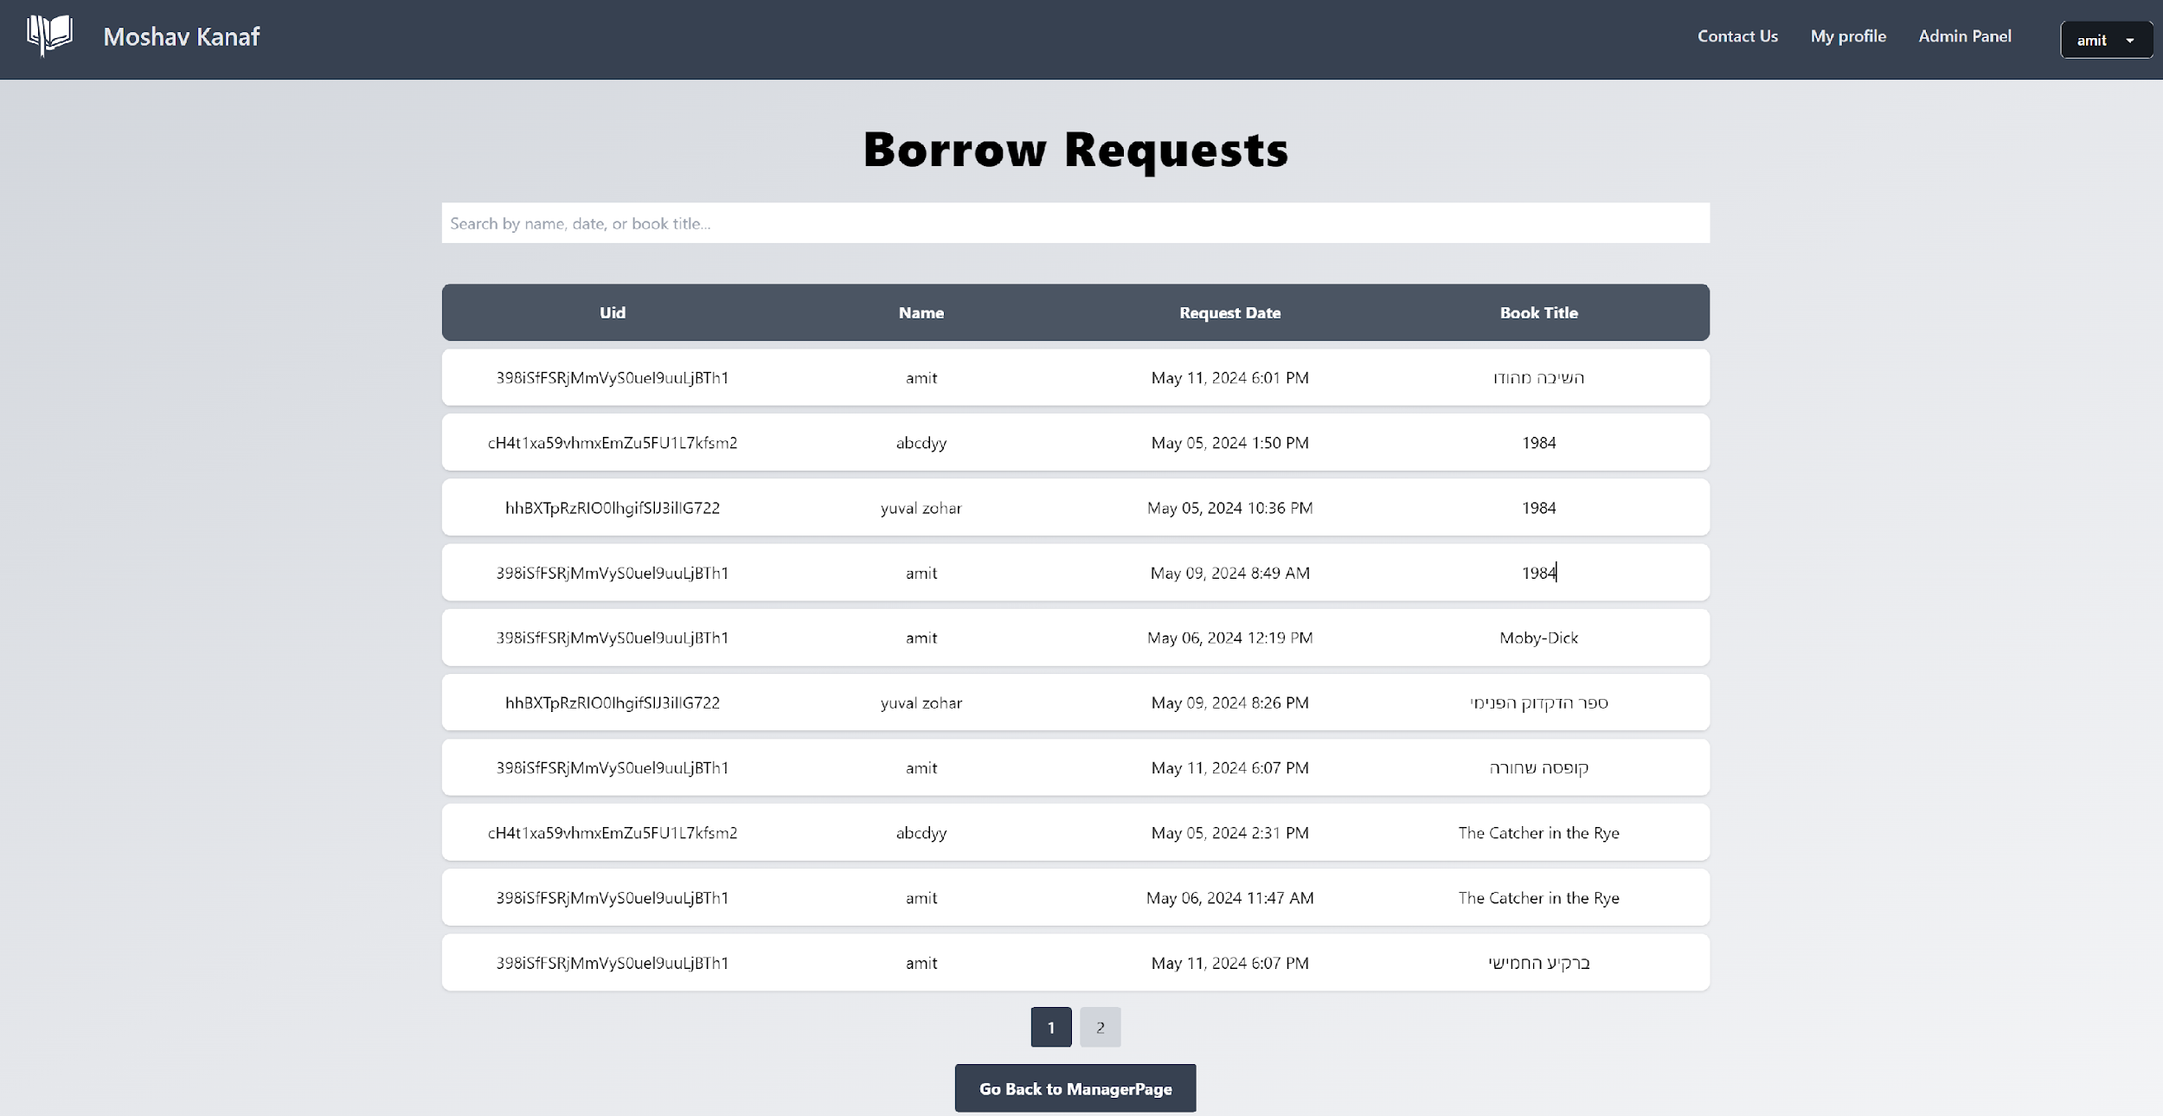

*Figure 24 - Screen: borrow requests page*

In this screen, the admin can see all the copies of each book and update the status of each copy.

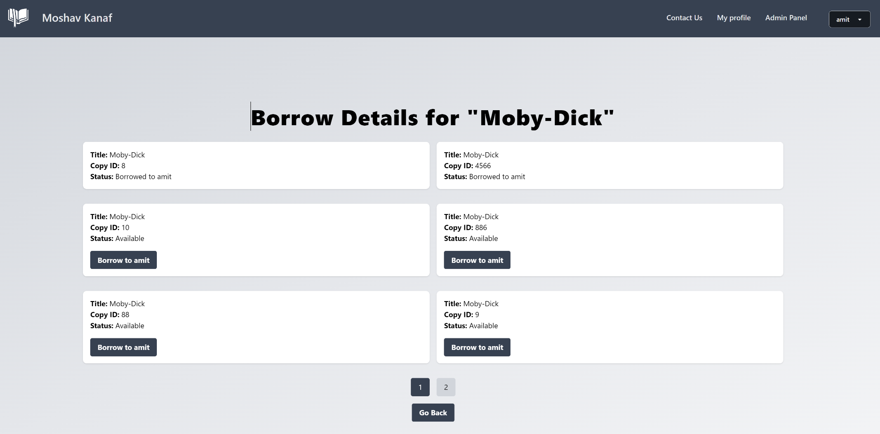

*Figure 25 - update book copy page*

### 3.2.5 Tests

Testing is a critical aspect of ensuring the functionality and reliability of our library's website. At every stage, from the initial code writing to the final implementation, thorough testing is essential. We need to test every component and feature that our website offers, including user login, user signup, admin login, book addition, ordering, and updating a book. In addition to testing the intended functionalities, we must also incorporate rigorous error checking mechanisms. This includes scenarios such as attempting user login with an incorrect or too short password and verifying the validity of the application's data after a sudden restart.

To further enhance our testing framework, we intend to use Jest [10], a comprehensive and powerful JavaScript testing framework developed by Facebook. Jest is well-suited for projects using React, Vue, Angular, or Node.js, making it a versatile tool for a wide range of JavaScript applications. It enables us to perform automated tests to validate both the functionality and stability of our website across different modules and interactions. With Jest, we can simulate user actions such as clicks, input entries, and form submissions, and then check the responses to ensure that every part of the user interface reacts correctly under various circumstances. This is crucial for verifying those interactions like logging in, signing up, or updating content work seamlessly for the end-user.

This integration of Jest into our testing strategy will help us ensure that our website operates smoothly and reliably, providing users with a seamless experience.

Here are some specific tests we will include to cover the critical functionalities and interactions on our website:

| **Expected result** | **Test description** | **Test** **name** |
| --- | --- | --- |
| The user will get to homepage. | Email : “user@gmail.com”  Password:"123456"  Press: "Login". | User login successfully |
| The manager will get to manager’s homepage. | Email : “manager@gmail.com”  Password:"123456"  Press: "Login". | Manager login successfully |
| error message: “Invalid email or password” is displayed on the screen. | Email : “user@gmail.com”  Password:"0000"- Wrong Password  Press: "Login". | User fails to login |
| error message: "User is already logged in" is displayed on the screen. | Email : “user@gmail.com”  Password:" 123456"  Press: "Login".  Opening the app in different browser and trying to login again with the same user | Login user that already logged |
| Move to “more Information” page. | click the "signup" button and write:  Email : “user@gmail.com”  Password:" 123456"  Confirm password: "123456"  Press: ”Create account” | Sign Up new user |
| error message: "Password should be at least 6 characters" is displayed on the screen. | click the "signup" button and write:  Email : “user@gmail.com”  Password:" 12345"  Confirm password: "12345" – 5 characters  Press: ”Create account” | Sign Up short password |
| error message: "Password and confirm password do not match" is displayed on the screen. | click the "signup" button and write:  Email : “user@gmail.com”  Password:" 1234566"  Confirm password: "1234577"  Press: ”Create account” | Sign Up 2 different passwords |
| error message: "missing password” is displayed on the screen. | click the "signup" button and write:  Email : “user@gmail.com”  Password:""  Confirm password: ""  Press: ”Create account” | Sign up with missing fields |
| Success message: "The book was added successfully ” is displayed on the screen. | Sign in to Manager and click the "Add new book" button.  Title: “The Catcher in the Rye”  Author's Name:” J.D. Salinger  Copies: 2  Copy ID1: 123  Copy ID2: 124 | Add new book successfully |
| error message: “Title, author, and copy ID are required” is displayed on the screen. | Sign in to Manager account and click the "Add new book" button.  Title: “”  Author's Name:” J.D. Salinger  Copies: 1  Copy ID1: 123 | Add a book with missing fields |
| Success message: "The book was updated successfully ” is displayed on the screen. | Sign in to Manager account and click the "Update a book" button.  Title: “The Catcher in the Rye”  Author's Name:” J.D. Salinger  Copies: 2  Copy ID1: 123  Copy ID2: 222 | Update a book successfully |
| Success message: "The book was ordered successfully ” is displayed on the screen. | Sign in to user account, chose a book and click the "Order" button when the book is available | Order a book |

# 4. Expected Achievements

The transformative digital library system project for Moshav Kanaf aims to significantly improve the current outdated system by involving modern technologies and an recommendation system to enhance both the user experience and accessibility. Here are a few of the key expected achievements:

1. **Development of a User-Friendly Interface**: A modern, intuitive interface that allows users to easily navigate the digital library, search for resources, and access recommended content. The interface will be designed to be accessible on various devices, including desktops, tablets, and smartphones, ensuring users can access the library from anywhere. Additionally, the system will be user-friendly for users with limited technological knowledge, making it accessible to a broader audience.
2. **Implementation of Key Ideas from Requirements Gathering and Data Collection**: According to the requirements that gathered through the initial data collection phase, particularly from interviews conducted with the library staff and questionnaires distributed to users. This includes adapting the system to address specific needs, preferences, and suggestions that emerged from these engagements, ensuring that the final product closely meets the demands of the community and enhances the overall user experience.
3. **Recommendation System**: Implementation of artificial intelligence (AI) through a web scraping algorithm that analyzes user behavior, preferences, and interactions within the library to offer personalized content recommendations. This system will use machine learning techniques to continually improve its recommendations as it learns more about each user's interests. Due to limited data on Hebrew books, we utilized a web scraper to extract recommendations from e-vrit and other websites which offering AI-based book suggestions in Hebrew with substantial data.
4. **Migration to Modern Technologies**: Transition from the obsolete Microsoft Access-based system to a robust, scalable platform built on modern technologies. This includes the use of cloud computing for storage and computing resources, ensuring the library system is reliable, scalable, and can handle concurrent user requests efficiently.
5. **Digital Resource Management System**: System for managing digital resources. This system will facilitate the cataloging, storage, and fetching of digital resources, making it easier for library staff to manage the library's collection and for users to find and access materials.
6. **User Account Management and Analytics Dashboard**: Development of a secure user account management system that allows users to create and manage their profiles, track their reading history, and receive recommendations.

In essence, our solution focuses on leveraging artificial intelligence through web scraping of websites that employ AI recommendation systems. This enables us to deliver a customized reading experience while enhancing the digital interface to ensure ease of use. By addressing these key areas, we aim to significantly elevate the value and appeal of digital libraries, making them more engaging and accessible for users worldwide.

## 4.1 Success Criteria

The project's success will be measured against the following criteria:

1. **User Engagement and Satisfaction**: An increase in the usage of the digital library and positive feedback from users, indicating that the system meets their needs and preferences.
2. **System Performance and Reliability**: High availability and low response times of the digital library system, with minimal downtime and technical issues.
3. **Assessment Rate by Users and Staff**: A large number of the library's user base and staff actively using the new system for accessing and managing digital resources.
4. **Accuracy of Recommendations**: User feedback and analytics demonstrating that the recommendation system effectively suggests relevant and engaging content to users.
5. **Operational Efficiency**: Improved efficiency in managing digital resources and providing library services, as evidenced by reduced operational costs and time spent on administrative tasks.

By achieving these objectives, the project will significantly enhance the library experience for users and staff at Moshav Kanaf, ensuring the library's services are accessible, personalized, and technologically advanced.

# 5. Conclusions

The modern library goes beyond being just places where books are kept. They have become dynamic centers of knowledge and resources. But this shift comes with its own challenges, especially in helping people find and access the content that suits their interests and needs. Our project tackles these issues by introducing a new book recommendation system for our digital library website. Digital libraries face big obstacles that stop them from working well. Many still use old technologies like Microsoft Access, which can hold back how well they work and how much they can grow. Also, they often don't give personalized recommendations, so users don't get suggestions that would make their reading experience better. On top of that, some libraries have systems that are hard to use, making it tough for people to get to the knowledge the libraries have.

Our idea is to make digital libraries much better by using advanced technology. Since there is no huge database or special system for Hebrew books for training AI models, we have come up with a different plan to use AI for making book suggestions. We'll use a special system to collect data and make recommendations based on what each person likes to read.

Our project helps all kinds of libraries, from small ones with old systems to bigger ones that need to catch up with the latest technology. By using our recommendation system and updating their digital systems, they can give users a better experience and make it easier for them to find books they like.

In short, our project aims to make digital libraries more modern, personal, and easy to use, so they can stay important in the digital age.

# 6. References

[1] Abdurakhimovich, U. A. (2023). The Vital Role of Web Programming in the Digital Age. Journal of Science-Innovative Research in Uzbekistan, 1(6), 42-51.‏

[2] Díaz-Oreiro, I., López, G., Quesada, L., & Guerrero, L. (2019). Standardized questionnaires for user experience evaluation: A systematic literature review. *UCAml 2019*, 14.‏

[3] Fanqi, Wei & Yan, Zhang & Xiaoping, Feng. (2017). Design and Implementation of Digital Library. 10.2991/icemc-17.2017.249.

[4] Fox, E. A., & Ingram, W. A. (2020, August). Introduction to digital libraries. In Proceedings of the ACM/IEEE Joint Conference on Digital Libraries in 2020 (pp. 567-568).‏

[5] Ko, H., Lee, S., Park, Y., & Choi, A. (2022). A survey of recommendation systems: recommendation models, techniques, and application fields. *Electronics*, *11*(1), 141.‏

[6] Liu, M. (2022). Personalized Recommendation System Design for Library Resources through Deep Belief Networks. *Mobile Information Systems*, *2022*

[7] Mihai, G. (2020). Comparison between relational and NoSQL databases. *Econ. Appl. Inform*, *3*, 38-42.‏

[8] Tao, H., Niu, X., Fu, L., Yuan, S., Wang, X., Zhang, J., & Hu, Y. (2022). DeepRS: A Library of Recommendation Algorithms Based on Deep Learning. *International Journal of Computational Intelligence Systems*, *15*(1), 45.

[9] Zhang, Q., Lu, J., & Jin, Y. (2021). Artificial intelligence in recommender systems. Complex & Intelligent Systems, 7, 439-457.‏

[10] <https://jestjs.io/>

[11] <https://cheerio.js.org/>

[12] <https://pptr.dev/>

## 6.1 Books websites links

[Israel Digital (libraryreserve.com)](https://telaviv.libraryreserve.com/10/50/en/Default.htm)

[Home - Global Digital Library - Global Digital Library](https://digitallibrary.io/)

[Home - UNESCO Digital Library](https://unesdoc.unesco.org/)

[e-vrit](https://www.e-vrit.co.il/)

[steimazky](https://www.steimatzky.co.il/)

[audible](https://www.audible.com/)

# 7. GIT

[LibrarySystemFinalProject/LibMoshavKanaf (github.com)](https://github.com/LibrarySystemFinalProject/LibMoshavKanaf)‏

# 8. AI Tools

The AI language models that we used are: [Claude](https://claude.ai/) , [ChatGPT](https://chatgpt.com/)

## 8.1 Prompts examples

**Query:**   
please make it in higher language and correct syntax errors:

This will help them make their recommendation systems better, so they can give each user more of what they like. This improvement makes their service more valuable to current users and shows that they're ahead in using new technology in libraries. Also, using our solution can make users happier and more likely to stick around because they get a library service that's easier to use and works better for them.

**Query:**

Please explain about hybrid recommendation systems

# 9. Appendix

## 9.1 Users questionnaire

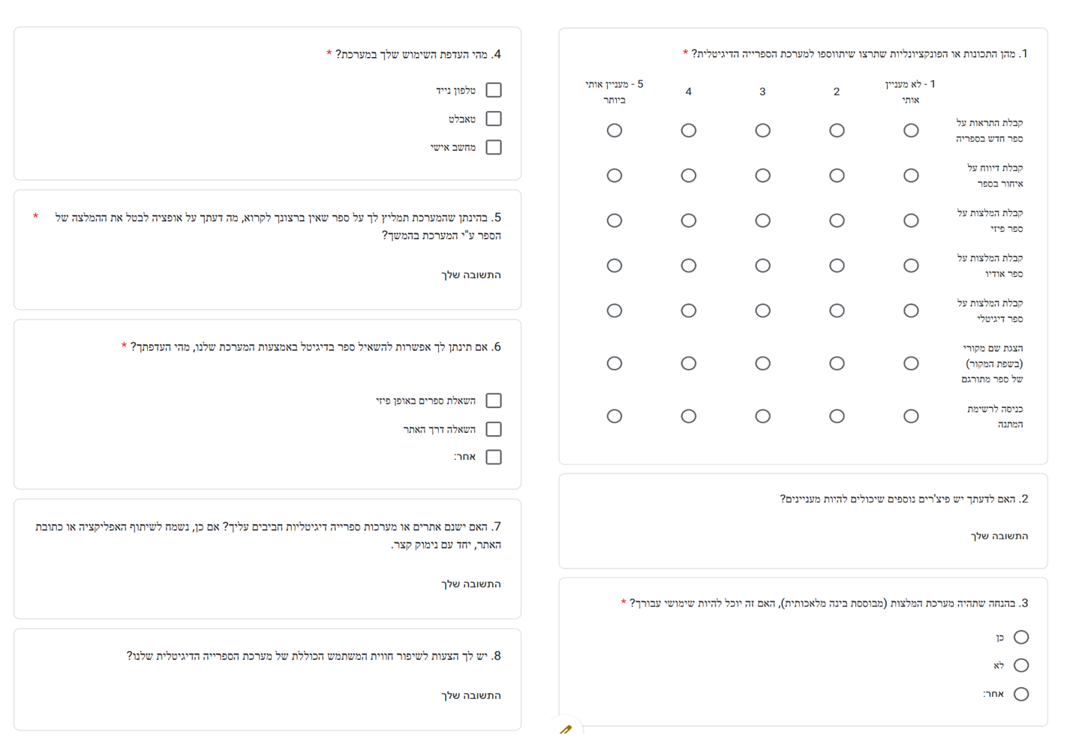

*Figure 26 - Appendix: Users questionnaire*